SET 18: Product Inventory Management
Aim
To visualize and analyze product inventory data using a bar chart, stacked bar chart, table, and a Tableau dashboard.
Data: PRODUCT INVENTORY
Product ID | Product Name | Quantity Available | Price ($)
1 | Product A | 250 | 20
2 | Product B | 175 | 15
3 | Product C | 300 | 18

PROGRAM 1: Bar Chart of Product Quantity
Create a bar chart to visualize the quantity available for each product.
library(ggplot2)

inventory <- data.frame(
Product_ID = c(1, 2, 3),
Product_Name = c("Product A", "Product B", "Product C"),
Quantity = c(250, 175, 300),
Price = c(20, 15, 18)
)

ggplot(inventory, aes(x = Product_Name, y = Quantity)) +
geom_col(fill = "seagreen") +
labs(
title = "Quantity Available by Product",
x = "Product Name",
y = "Quantity Available"
) +
theme_minimal()
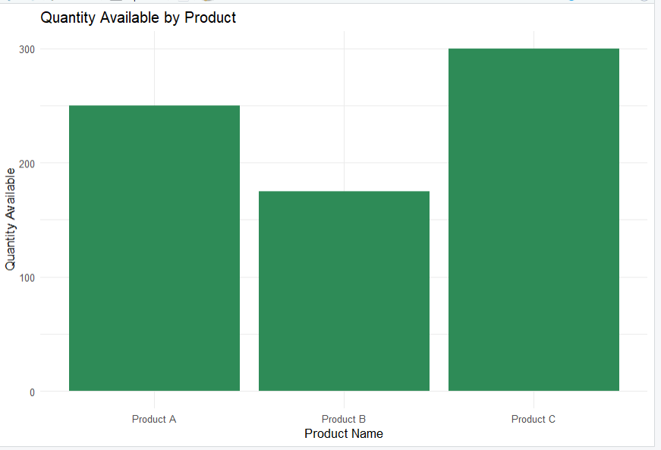
Output 1: Product Inventory Bar Chart
Observation: The bar chart shows that Product C has the highest available quantity of 300 units, while Product B has the lowest quantity of 175 units.

PROGRAM 2: Stacked Bar Chart of Product Categories
Generate a stacked bar chart to show the quantity of each product within different product categories.
library(ggplot2)

inventory <- data.frame(
Product_Name = c("Product A", "Product B", "Product C"),
Category = c("Category 1", "Category 2", "Category 1"),
Quantity = c(250, 175, 300)
)

ggplot(inventory, aes(x = Product_Name,
y = Quantity,
fill = Category)) +
geom_col() +
labs(
title = "Product Quantity by Category",
x = "Product Name",
y = "Quantity Available",
fill = "Product Category"
) +
theme_minimal()
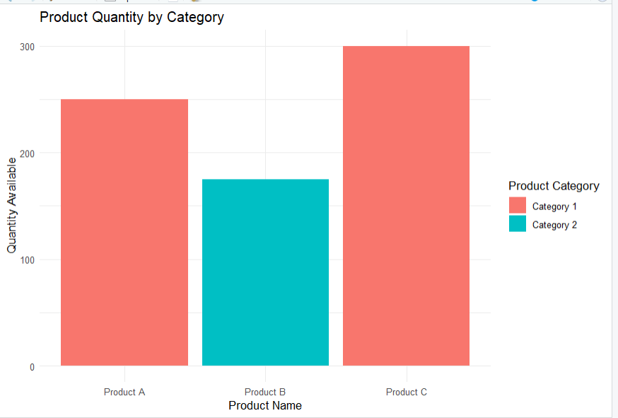
Output 2: Product Quantity Stacked Bar Chart

Observation: The stacked bar chart displays product quantities using different colours for the illustrative categories. Actual category information is needed for a meaningful category-wise analysis.
Note: The supplied dataset does not contain a Product Category column. The following code uses illustrative categories to demonstrate the chart.

PROGRAM 3: Table of Product Inventory Data
Build a table to display the inventory information for each product.
inventory_table <- data.frame(
Product_ID = c(1, 2, 3),
Product_Name = c("Product A", "Product B", "Product C"),
Quantity_Available = c(250, 175, 300),
Price = c(20, 15, 18)
)

print(inventory_table)
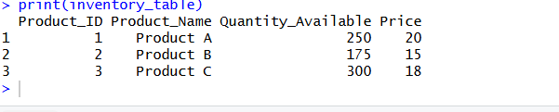
Output 3: Product Inventory Table
Observation: The table displays the product ID, product name, available quantity, and price of each product.

PROGRAM 4: Tableau Dashboard for Product Inventory
Procedure
- Open Tableau and connect to the Product Inventory dataset.
- Create a bar chart using Product Name and Quantity Available.
- Create a stacked bar chart using Product Name, Quantity Available, and Product Category on Color. Add the actual category column to the dataset if available.
- Create a table containing Product ID, Product Name, Quantity Available, and Price.
- Create a new Dashboard in Tableau.
- Add the bar chart, stacked bar chart, and table to the dashboard.
- Arrange the visualizations properly.
- Add filters for Product Name and Product Category.
- Give the dashboard the title “Product Inventory Dashboard”.
- Save the Tableau dashboard.
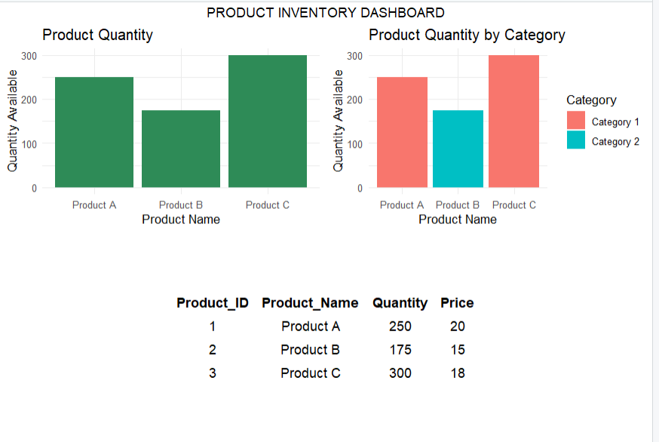
Output: Product Inventory Dashboard
Observation: The dashboard combines product quantity charts and an inventory table. It helps users compare available stock and review product information in one view.

Set 18 Procedure
- Create a product inventory dataset containing product ID, product name, quantity available, and price.
- Use R to create a bar chart showing the quantity available for each product.
- Create a stacked bar chart to visualize product quantities across categories.
- Create a table displaying the inventory data for each product.
- Import the inventory dataset into Tableau.
- Create the bar chart, stacked bar chart, and table in Tableau.
- Combine the visualizations into a dashboard for interactive exploration.
Set 18 Result
Product inventory data was successfully visualized using a bar chart, stacked bar chart, and table. A Tableau dashboard was designed to provide a clear view of product quantities, prices, and category-wise inventory.

